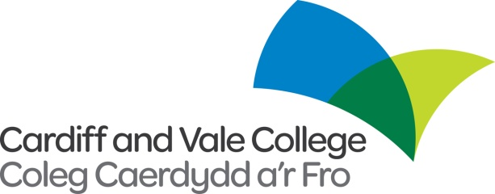

**Internal / External Vacancy**

**Job Title:** Assistant Rugby Coach (Attack and Skill Focus)

**Contract:** Part time, hourly paid (7 hours/week, Term time only) Fixed term until 28/04/23.

**Location:** CISC, City Centre Campus and some travel around Cardiff

**Salary:** £11.30-12.30 per hour

Cardiff and Vale College is seeking to appoint an Assistant Rugby Coach, specifically focussing on Attack and Skills.

In all aspects of the job, the Assistant Coach is answerable to the Head of Rugby, with linkages to the Sport, Tourism and Public Services department Head and Deputy.

We are looking for a passionate, committed individual who can deliver excellence, with a willingness to actively participate in CAVC life. Responsibilities include:

Supporting the Head of Rugby in the planning, coordination and delivery of the rugby performance programme, to include:

* Ongoing achievement of the WRU A licence.
* Regional partnership agreed performance indicators in 15s and 7s.
* A focus on successful delivery of NCL and AoC National League squads.
* Facilitating a student player centred culture and environment both on and off the field.
* Player communication and individual feedback.
* Recruitment activities including widening participation.
* Welsh language skills would be desirable for this role.

The ideal candidate will hold a National Governing body coaching qualification at Level 2, or Level 3; will have an understanding of elite sport, including student athletes, environments, support, coaching and services provided and will possess a good understanding and experience of developing individual performance plans for student players.

Please be advised that working in performance sport will require you to work flexible hours in line with student athletes training schedules, this may include early morning, evening and weekend work.

Further information regarding the role, the person specification and job competencies is contained in the attached job description.



Applications are to be made using the Cardiff and Vale College application form only. The college welcomes applications in Welsh. Applications submitted in Welsh will not be treated less favourably than an application in English. If we invite you to interview, let us know if you would like us to conduct the interview and assessment process in Welsh.

**The closing date for completed applications 06/10/2022 at midday.**

To find out more or apply go to [www.cavc.ac.uk](http://www.cavc.ac.uk) or contact the Human Resources Department on 02920250311 or recruitment@cavc.ac.uk.

All vacancies are subject to a Disclosure and Barring Service (DBS) check and employment will not commence without a valid up to date DBS check. This is a contractual agreement that must be in place before your employment starts. The College’s procedure for the Suitability of Ex-offenders for Employment is available upon request.

**These are contractual agreements that must be in place before your employment can commence.**

We are committed to the recruitment and retention of disabled people, and are a positive disability confident scheme employer.

 cid:image005.jpg@01D77EFE.93A73200 