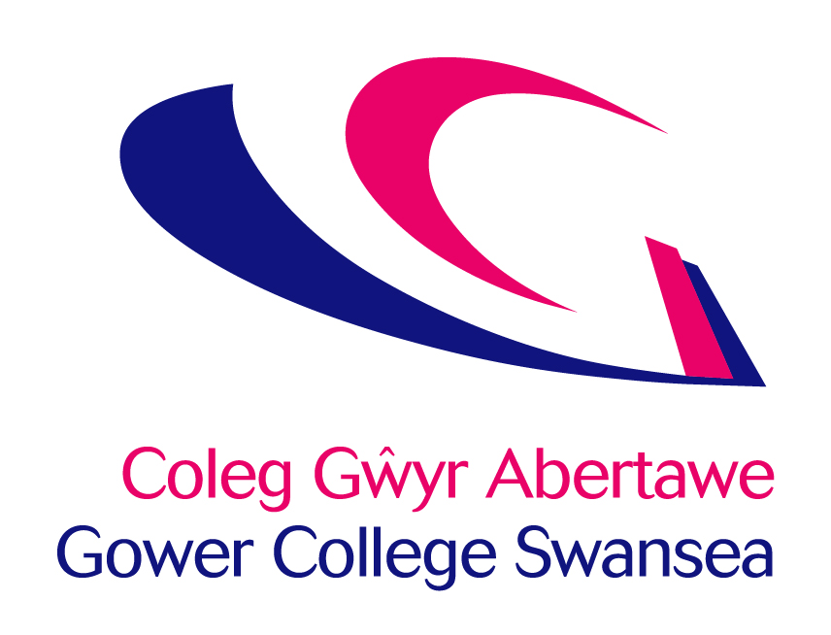
Job Description
Post: | Tutor Assessor – ACS Gas, Plumbing & Renewable Technologies
Accountable to: | LAM Construction
Department: | Construction

Job Purpose
The post involves tutoring and assessing learners within the Mechanical Building Services Sector including but not limited to:

- Plumbing and Heating
- Domestic and Commercial Gas Installation and Maintenance including ACS assessment, and Managed Learning Pathways
- Renewable technologies including Heat Pumps, Solar Thermal
- Mechanical Heat Recovery and Ventilation

To enable industry to undertake work within the relevant Competent Persons Schemes you would be involved in the delivery and assessment of the following programs:

- Water Regulations
- Vented and Unvented Hot Water Systems
- Energy Efficiency in Domestic Dwellings
- Domestic and Commercial ACS Gas
- Domestic Heat Pump Installer
- Solar Thermal Installer
- Legionella Risk Assessment

This is growing an exciting and list and may vary depending on demand.

You will need to have a professional approach, good people skills and have up to date knowledge of the industry and be capable of undertaking duties to a high standard.

Key Responsibilities:

- Teach and assess learners within the Mechanical Building services sector, predominantly ACS Gas, Plumbing & Renewable Technologies together with bespoke short sharp courses for both external and internal learners on, and possibly off site.

- Work within the team to assess and internally verify learner’s portfolios to ensure they meet the requirements of the various external verifiers and awarding bodies.

- Work with customers in industry to maintain and build relationships and to secure contracts with existing and new organisations.

- Provide a high level of customer service to secure contracts by providing the sales team and customers with full access to information on courses and training available to industry.

- Will work within the requirements of the Common Inspection Framework to provide a high quality teaching and learning experience for all learners.

- To provide a learning environment that is flexible and productive using a variety of teaching and assessing methods including the utilisation of ICT when appropriate.

- The ability to support learners with basic skills and be able to embed support for basic skills into the vocational area via ILP’s, Action planning, and reviewing of learners’ development and progression.

- To establish and maintain monitoring and review arrangements for learners undertaking training.

- To maintain accurate records of student activity and report detailed information to Line Manager as required.

- To work within the team to share best practice, develop existing and new programs and support colleagues.

Other Tasks

- Comply with all College Policies & Procedures, keeping abreast of any changes and updating practice and/or systems to ensure continued compliance.

- Ensure that all aspects of the College Financial Regulations are followed.

- Contribute to and represent the overall vision and values of the College.

- Ensure that all services are delivered in compliance with the Welsh Language Standards.

- To flexibly respond to the needs of the business and to provide an effective service to our learners and other stakeholders.

PERSONAL DEVELOPMENT
In partnership with the College, take responsibility for personal development, including:
1. Participating in an annual staff review and identifying development needs.
2. Updating of professional, teaching and training skills and qualifications, through attending staff development opportunities, joining professional bodies and keeping informed of educational and professional initiatives.

Health & Safety

All employees have a statutory duty of care for their own personal safety and that of others who may be affected by their acts or omissions. Staff are required to co-operate with management to enable the College to meet its own legal duties and to report any hazardous situations or defective equipment.

General

This description is not intended to establish a total definition of the job, but an outline of the responsibilities you are expected to undertake. From time to time you may be required to undertake any other duties commensurate with your level of responsibility.

This is a description of the job as it is at present constituted. It is the practice of the College periodically to examine employees’ job descriptions and to update them to ensure that they relate to the job as then being performed, or to incorporate whatever changes are being proposed. You will, therefore, be expected to participate in any discussions relating to Job Description change.

Person Specification – Tutor/Assessor ACS Gas, Plumbing & Renewable Technologies

In your application you are asked to address only those criteria labelled A. These will be used to shortlist applicants. Criteria labelled I will be explored at interview and those labelled WRE in assessment centre activities.

Criteria | Essential | Desirable | Method
Qualifications: | - Level 3 or equivalent qualification in Gas installation and maintenance or related subject such as Plumbing / Heating and Ventilation  - Current ACS Gas certification, as a minimum CCN1, CENWAT, CPA1, HTR1, CKR1, CoNGLPG PD  - Current certificates for: Unvented Hot Water certificate (G3), Water Regulations, Energy Efficiency (Part L)  - Current ACS certification in Non domestic areas of gas installation and maintenance, or a strong desire to work towards | - Experience and occupational competence to assess NVQs at Level 1-4 or equivalent would be advantageous  - TAQA – Assessor Award and/or V1 Internal Verifiers award or equivalent would be advantageous.  - Teaching Qualification – PGCE/Cert Ed and/or PTTLS or equivalent would be advantageous | A  A  A  A  A
Knowledge & Experience: | - Proven track record of working in Mechanical Building Services role and environment.  - Commercial knowledge, experience and understanding of industry including training needs.  - Understanding of the importance of building and maintaining effective working relationships with employers |  | A/I  A/I  A/I
Skills & Abilities: | - Excellent verbal and written communication skills.  - Excellent interpersonal skills  - Strong administrative skills.  - Attention to detail.  - Able to work on own initiative.  - Excellent IT and/or ILT skills. |  | A/I  I  A/I  A/I  I  A/I
Personal Attributes: | - Creative, innovative and enthusiastic.  - Able to work and under pressure and to deadlines.  - Commitment to continual professional development.  - Target driven.  - Quality focus.  - Professional, ethical and confident in approach and image.  - Able to work independently and as part of a team. |  | I  I  I  I  I  I  I
Special Requirements: | - Flexibility.  - Must be willing to undertake further training.  - Prepared to visit employers over a wide geographical area. | - Welsh Language Skills –Entry Level (See detailed Language Level Descriptors attached) | A

A – Application Form I – Interview WRE – Work Related Exercise

ISGRIFYDD LEFEL IAITH GYMRAEG
WELSH LANGUAGE LEVEL DESCRIPTORS

Welsh Essential | LEVELS | Listening | Speaking | Writing | Reading
 | Level 4  Proficient | Able to understand all conversations involving work | Fluent – able to conduct a conversation and answer questions, for an extended period of time where necessary | Skilled – able to complete complex written work without the need for revision | Able to understand all material involving work
 | Level 3  High | Able to follow the majority of conversations involving work including group discussions | Able to speak the language in the majority of situations using some English words | Able to prepare the majority of written material related to the area, with some assistance in terms of revision | Able to read the majority of material in own area
 | Level 2  Intermediate | Able to follow routine conversations involving work between fluent Welsh speakers | Able to converse with someone else, with hesitancy, regarding routine work issues | Able to draft routine text, with editing assistance | Able to read routine material with a dictionary
 | Level 1  Foundation | Able to understand a basic social conversation in Welsh | Able to answer simple enquiries involving work | Able to answer simple correspondence with assistance | Able to read basic material involving work (slowly) and understand text that consist mainly of high frequency everyday work related language
Welsh Desirable | Entry | Able to understand basic enquiries in Welsh (“Ble mae…? Ga’ i siarad â…?”) | Able to conduct a general conversation (greetings, names, sayings, place names) | Able to write basic messages (“Diolch am dy help.”) | Able to understand and read very short, simple texts
 | None | No Welsh language skills at all | No Welsh language skills at all | No Welsh language skills at all | No Welsh language skills at all

DISGRIFYDD LEFEL IAITH GYMRAEG
WELSH LANGUAGE LEVEL DESCRIPTORS

Cymraeg Hanfodol | LEFEL | Gwrando | Siarad | Ysgrifennu | Darllen
 | Lefel 4  Rhugl | Gallu deall pob sgwrs yn ymwneud a’r gwaith | Rhugl – gallu cynnal sgwrs a gofyn cwestiynau, am gyfnod estynedig pan fod angen | Medrus – gallu cwblhau gwaith ysgrifenedig cymhleth heb angen adolygu | Gallu deall deunyddiau yn ymwneud a’r gwaith
 | Lefel 3  Uchel | Gallu dilyn y mwyafrif o sgyrsiau yn ymwneud a’r gwaith yn cynnwys trafodaethau grwp | Gallu siarad yr iaith yn y mwyafrif o sefyllfaoedd gan ddefnyddio rhai geiriau Saesneg | Gallu paratoi'r mwyafrif o waith ysgrifenedig yn ymwneud a’r maes, gyda pheth cymorth o ran adolygu | Gallu darllen y mwyafrif o ddeunyddiau yn fy maes
 | Lefel 2  Canolradd | Gallu dilyn sgyrsiau arferol yn ymwneud a gwaith, rhwng siaradwyr Cymraeg rhugl | Gallu sgwrsio gyda rhywun arall am faterion gwaith arferol, ond yn petruso | Gallu drafftio testun arferol, gyda chymorth golygu | Gallu darllen deunyddiau arferol gyda geiriadur
 | Lefel 1  Sylfaen | Gallu deall sgwrs gymdeithasol sylfaenol yn Gymraeg | Gallu ateb cwestiynau sylfaenol yn ymwneud a’r gwaith | Gallu ateb gohebiaeth gyda chymorth | Gallu darllen deunyddiau syml yn ymwneud a gwaith (yn araf) a gallu deall testun sy’n cynnwys iaith gwaith pob dydd yn bennaf
Cymraeg Dymunol | Mynediad | Gallu deall ymholiadau sylfaenol yn Gymraeg (“Ble mae…? Ga’ i siarad â…?”) | Gallu cynnal sgwrs gyffredinol (cyfarchion, enwau, dywediadau, enwau llefydd) | Gallu ysgriffennu negeseuon sylfaenol (“Diolch am dy help.”) | Gallu deall a darllen testunau byr, syml iawn
 | Dim | Dim sgiliau Cymraeg o gwbl | Dim sgiliau Cymraeg o gwbl | Dim sgiliau Cymraeg o gwbl | Dim sgiliau Cymraeg o gwbl

