
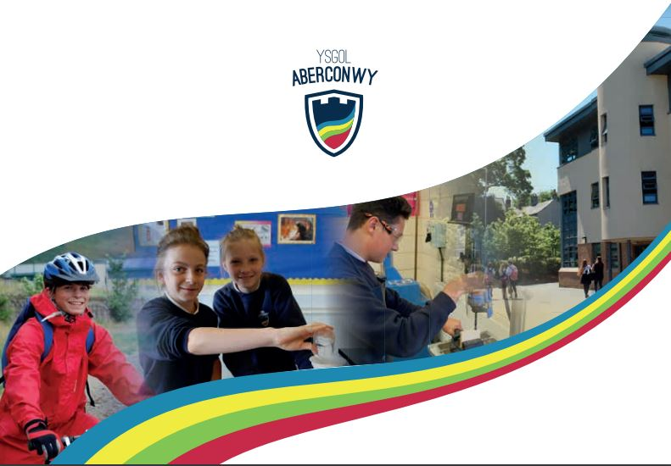
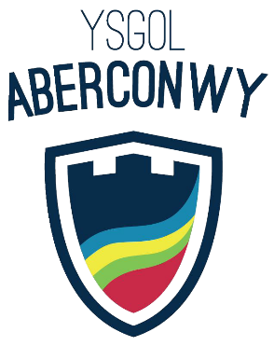
Onsite Inclusion Centre Coordinator

Fulltime, permanent position.

Start date : September 2026

Salary details : MPS/UPS + TLR2a

Applicant Information Pack
Headteacher’s Welcome

I would firstly like to thank you for your interest in the post of OSIC Coordinator at Ysgol Aberconwy. The purpose of this information pack is to help you get to know more about our school and help you to decide if this is the right post for you.
Ysgol Aberconwy is a school that puts learning and individual achievement at the heart of everything it does. We want every pupil to succeed; to achieve their full potential, be prepared for the future and become confident, thoughtful young people so they leave us ready for the challenges of an exciting and increasingly competitive world. This philosophy also extends to the school’s staff – we seek to be a learning organisation that focuses on the development of each individual within it through coaching, challenge and support.
Situated in a spectacular location on the Conwy estuary, the school boasts a modern, well maintained and well equipped environment. Whilst the school’s ethos is based on traditional values of respect, responsibility and community spirit, students experience the very latest technology and teaching methods in the classroom.
Here at Ysgol Aberconwy we have the highest expectations of all our pupils in all areas of school life. Academic standards are important to us and we expect all pupils to achieve the very best. We also have the highest expectations of our pupils when it comes to behaviour, attendance, punctuality and uniform.
The pastoral system at Ysgol Aberconwy is extensive and innovative. Each year group has a full time non-teaching Guidance Mentor. Working from a key stage base these mentors are available throughout the day to respond to pupils’ concerns and to provide a direct contact point for parents. This, along with our specialist resource centre for ALN pupils ensures that all pupils feel secure and supported at school.
We have a flourishing extra-curricular programme. This includes a full range of sporting activities in the school’s state of the art facilities as well as music concerts and drama productions. The school owns its own field centre in the hills above Abergwyngregyn and has an extensive outdoor activities programme.
We are also proud of our Welsh tradition and heritage. The school encourages the use of the Welsh language in lessons and beyond, and we are developing the provision of some subjects through the medium of Welsh for those who want it.
We are very fortunate to have a dedicated and highly professional team of teachers and support staff who expect the very highest standards from all our staff and pupils, whilst our strong school systems ensure that everyone learn in a safe and friendly environment where teachers teach and learners learn.
Ysgol Aberconwy is a great place to work. It is focused on teaching and learning and dedicated to the well-being of our learners. We have the highest expectations of all who work here and therefore, we are only looking for the finest staff to work with our pupils. We know that our school can only be as good as the staff within it. If you would like to see for yourself why we believe Ysgol Aberconwy is a great school in which to work, then please contact us for a visit.

Ian Gerrard

Additional Information about the school

During their visit to the school in October 2025, ESTYN report that :
- Many pupils behave well in lessons.
- Many teachers establish purposeful working relationships with pupils.
- In many lessons, pupils engage well and respond to staff expectations.
- At Key Stage 4 and in the sixth form, the curriculum is broad and well-balanced.
- Pupils value the wide range of trips and visits, which contribute to their strong connection with, and respect for, their school.
- Ysgol Aberconwy is a caring and inclusive community where pupils feel safe, valued and respected.
- Relationships between staff and pupils are supportive.
- Many pupils behave well around the school.
- Pupils benefit from meaningful opportunities to develop their awareness of diversity.
- Diversity is celebrated throughout the school.
- Pupils are proud to be part of their school community.
- The school offers a wide range of extra-curricular clubs, which are well attended.
- The school provides a range of supportive environments where pupils feel nurtured.
- The learning resource bases provide calm, supportive environments that promote security and emotional regulation.
- Strong relationships between staff and pupils characterise the learning environments in these bases.
- Pastoral staff respond appropriately to concerns, including incidents of bullying.
- Pupils receive impartial advice that helps them make informed decisions.
- The headteacher provides thoughtful leadership with inclusion and well-being at the heart of his vision.
- The school’s mission and values are well understood and embraced by pupils, staff and governors.
- The school places a strong emphasis on local identity (‘Cynefin’).
- Leaders promote the advantages of learning the Welsh language well.
- Many pupils have positive attitudes towards learning Welsh.
- Leaders have a clear vision for developing pupil leadership.
- There are meaningful opportunities for pupils to take responsibility.

Information about the local area

Conwy Town and Area
Conwy is a town rich in history, with much of it still preserved within the walls and traditional structures of its buildings. In the heart of it is the mighty 13th-century castle, whose walls encapsulate this remarkable medieval town.
Surrounded by the beautiful Welsh countryside and watched over by the mighty mountains of Eryri it’s a beautiful place to visit or to live. The Quay is host to a number of amenities and is a particularly stunning place to visit during the warm summer months. Whether you’d prefer to enjoy the hospitality of local restaurants, take an exciting boat tour around the coastal area or hike upon the many surrounding mountains – it’s all possible in and around the historical town of Conwy.
Conwy offers a whole host of places to eat and drink. Fine dining restaurants, traditional pubs and snug cafes can be found throughout the town. It’s also host to a number of hotels and B&Bs – many of which are incredibly close to the castle itself. With its traditional and quaint appearance, you may be fooled into thinking that this town is hard to access. It’s just over an hour’s drive from two major airports – Liverpool and Manchester – and easily accessible by train. It’s also worth exploring further afield in the rest of Conwy County which includes equally impressive coastal towns.
Llandudno has maintained its traditional and authentic charm. This Victorian seaside resort has much to offer its visiting guests. Take a leisurely walk along its promenade, or travel up to summit of the Great Orme where you’ll be rewarded with incredible views of its surrounding mountains and coastal towns.
You’ll also find that Conwy is very proud of its culture and history, and is often host to a number of cultural events throughout the year. Each year, you’ll find an abundance of festivals, art galleries and local markets, which are primarily hosted in the name of supporting and displaying their local talent and produce.
If you’re looking for somewhere to explore that is full of adventure and has also managed to maintain the rich history within its walls and buildings, Conwy offers its guests (and residents) all of this and more.
(http://www.conwy.com/)




Job Advert
Onsite Inclusion Centre Coordinator

Required from September 2026

This is a full time, permanent position.

Salary : Main/Upper Teaching Scale + TLR2a

Closing Date: Thursday 14th May

At Aberconwy, we have excellent provision for supporting pupils with additional learning needs, challenging behaviour, attendance and mental health. The OSIC is a part of this much larger centre within the school and supports pupils that are struggling to be able to access mainstream lessons. There is a large team that works together within the centre offering an engaging curriculum with a holistic approach to pupils’ wellbeing.
We therefore seek to appoint an enthusiastic and motivated Teacher to lead within our OSIC with the support of a teaching assistant. They will work under the guidance of the centre’s coordinator to manage the provision for students, particularly in the area of behaviour, social and emotional needs, and mental health to maximise achievement. They will coordinate with Heads of Department across the school in ensuring that they are able to deliver an engaging curriculum to those pupils within the OSIC and will work with other staff across the centre to ensure that each pupils’ needs are met.

In return, we offer you :
- A strong commitment to professional development;
- A school with high aspirations and a genuine opportunity to make a difference;
- An opportunity to help shape teaching and learning and our alternative curriculum;
- A dedicated and supportive team of professional staff and governors;
- Strong links with other local schools for partnership working and support;
- A strong community spirit;
- A vibrant and interesting place to work.

This is an exciting time to join Ysgol Aberconwy, a mixed 11-to-18 comprehensive school of over 1100 pupils. Set in its own extensive campus on the banks of the beautiful River Conwy, the school is situated in the medieval town of Conwy on the North Wales coast adjacent to the Eryri National Park. As a PFI School, we are exceptionally well resourced and maintained, and we have developed a significant reputation locally for the quality of our pastoral care as well as our academic success. Numbers in the school will have risen by 40% over the last five years in September, and we have developed specialist resource centres to support children with dyslexia, autism and other learning needs.

Job Description

POST: Teacher : On site inclusion centre Coordinator

SALARY RANGE: MPS/UPS + TLR2a

POSTHOLDER:

REPORTING TO: AHT & Centre Coordinator

JOB PURPOSE

- To manage the provision for students, particularly in the area of behaviour, social and emotional needs, and mental health to maximise achievement.

MAIN DUTIES

The Hafan Teacher will be expected to:
- Lead and manage the day to day running of Hafan, to promote inclusion and a successful return to mainstream lessons wherever possible.
- Manage the deployment of the TA assigned to Hafan on a day to day basis.
- Establish positive working relationships with students accessing Hafan.
- Liaise with subject teachers to ensure access to curriculum continuity and suitability of work in Hafan.
- Support students’ access to learning using appropriate classroom management and behavioural strategies to maximise opportunities in terms of educational attainment, improved attendance and overall social, emotional and behavioural development.
- Be fully conversant with the school’s ALN policy and be responsible for its application within Hafan.
- Follow the school’s behaviour policy when managing student behaviour and promoting self-control.
- Develop and implement Individual Education/Behaviour Plans ensuring daily targets are set for students with guidance from ALNCO and Ganolfan coordinator.
- Develop programmes to support behaviour, emotional and social needs, including Anger Management, Conflict Resolution, Self Esteem Development and Mentoring Programmes to enable students to make positive choices about their own behaviour.
- Develop constructive relationships with parents/carers, maintaining regular contact, through letters, email, telephone calls and meetings.
- Monitor and evaluate student progress and provide objective and accurate feedback and reports as required, to staff and parents, on students’ achievement, progress and other matters, ensuring the availability of appropriate evidence
- Consult with specialist staff and outside agencies in planning and evaluating as appropriate.
- Undertake classroom observations of students to determine support required and progress made.
- Liaise and consult with key members of school staff and outside agencies to develop alternative individual learning pathways for students as required.
- To provide a safe and attractive environment that places values on the students and their activities. To manage and develop resources efficiently and effectively.
- To support a comprehensive programme of extra-curricular clubs, revision lessons and educational visits.
- Collate data to be shared on a half-termly basis with the LT link and produce termly reports for the HT and Governors.
- Contribute to the professional development offered to school staff focusing on behaviour management and related issues in the context of social, emotional and behavioural difficulties.
- Be aware and comply with policies and procedures relating to Child Protection, Health and Safety, Confidentiality and Data Protection and report all concerns to key members of staff within the school.
- To undertake any other duties, in accordance with the post, as requested by the Headteacher.

Teaching and Learning
The Hafan Teacher will be expected to:
- To deliver outstanding lessons to all students in Hafan across a wide range of subjects to levels appropriate to individual student identified needs. This will necessitate detailed consultation with Heads of Department and subject teachers.
- To implement innovative strategies in the classroom which promote learning and engagement.
- Facilitate curriculum access by implementing effective differentiation strategies aimed at improving standards of attainment and behaviour.
- Devise, implement and review Individual Plans for those attending Hafan in consultation with key members of staff at the school, parents/carers and other relevant agencies.
- Monitor students’ academic progress and attainments and revise learning targets of teaching strategies as appropriate.
- Ensure accreditation is in place for students following alternative individual learning pathways in consultation with external vocational providers.

Additional Duties
- Manage one other TA within Hafan
- Liaise with the Ganolfan Coordinator and Assistant Head teacher responsible for Inclusion
- Attend meetings with parents and external agencies to discuss the progress of individual students.
- Work collaboratively with Y Ganolfan team.

Knowledge and Skills
- Can use ICT effectively in term of record keeping, reporting and supporting learning.
- Working knowledge and experience of implementing relevant learning strategies to students with additional learning needs.
- Ability to relate well to children and adults.
- Work constructively as part of a team.

RIGHT TO VARY

This job description is not intended to be an exhaustive list of duties. Ysgol Aberconwy reserves the right, after appropriate consultation with you, to vary your duties and responsibilities within the parameters of your grade

Person Specific
Factor | Requirements | How Identified | Rank  E- Essential  D-Desireable
Knowledge  & Skills | Good Honours Degree & achievement of QTS | AF/V | E
Knowledge  & Skills | Qualification relevant to working with children with ALN | AF/V | D
Knowledge  & Skills | Knowledge of Microsoft software packages, and experience of using word processing and spreadsheets packages | AF/I/R | D
Knowledge  & Skills | Ability to work under pressure to complete deliverables and adhere to deadlines. | AF/I | E
Knowledge  & Skills | Excellent organisational skills including an ability to manage own workload and plan activities. | AF/I | E
Knowledge  & Skills | Good communication skills in written and spoken English. | AF/I | E
Knowledge  & Skills | Fluency in Welsh Language | AF/I | D
Knowledge  & Skills | Knowledge and experience of using positive behaviour support strategies to manage and change challenging behaviour. | AF/I | E
Knowledge  & Skills | Knowledge of and commitment to the rights and interests of children and young people. | AF/I | D
Creativity & Innovation | Excellent personal motivation and enthusiasm for completing assigned tasks. | AF/I | E
Creativity & Innovation | Ability to research and organise information for inclusion in documents and reports. | AF/I/R | D
Creativity & Innovation | Ability to work independently and use initiative to solve problems and create solutions. | AF/I/R | D
Contacts & Relationships | Excellent interpersonal skills and an ability to communicate effectively, in both written and verbal form with staff, parents and external organisations. | AF/I | E
Contacts & Relationships | Ability to integrate into and work effectively within a variety of team environments. | I | E
Decisions/ Recommendations | Ability to recognise ways in which systems can be enhanced to maximise their effectiveness and present a coherent case for doing so | AF/I/R | E
Decisions/ Recommendations | Capable of making decisions as to prioritising work tasks and deadlines | AF/I | E
Resources | Responsible for the safekeeping of school digitalised assessment data. | I | E
Work Demands | Ability to respond effectively to regular interruptions and to deal with any conflicting priorities that may arise. | AF/I | E
Physical  Demands | The post is largely school based however some travel for training or meetings at other sites may be required. | AF/I | E
Physical  Demands | Ability to cope with a high level of computer system use. | AF/I | D

AF: Application Form I: Interview R: Reference V: Verification

Safeguarding Procedures

We are committed to the safeguarding and promotion of the welfare of children and expects all staff and volunteers to share this commitment. We are an Equal Opportunities employer. In this light, we would like to draw the following matters to your attention:

- All appointments are made subject to:
a. An enhanced DBS disclosure;
b. Checks of professional status (EWC; QTS etc.)
c. Confirmation of professional qualifications;
d. Receipt of strong references (if not received by the time of interview); and
e. Medical clearance

- We only accept applications completed on the Conwy application form with a covering letter. Please do not send CVs or open testimonials. More detail about the content of applications is provided in this pack below.

- Please ensure that application form is completed in full. In particular, you must ensure that a full work history is provided and that any gaps in your employment are fully explained.

- The referees cited in your application form must include your employer from the last occasion in which you worked with children. If your last employment was in a school, we would expect a reference from the Headteacher and/or Deputy/Assistant Headteacher.

- When seeking references, we will request information about your suitability to work with children.

- If you are shortlisted, any anomalies in your application will be discussed with you at interview.

- As a local authority, Conwy is committed to safeguarding children and vulnerable groups. All Council employees are expected to be aware of the Corporate Safeguarding Policy and their responsibility to report any concerns in the appropriate manner and timescales.

We encourage you to pay close attention to these matters so that your application is not excluded unnecessarily.

Application Procedures

If you wish to be considered for this vacancy you should complete the electronic application form, giving the names and addresses of two referees.

Please note that the section for “Additional information to support your application” should include the following information:
- A brief outline of what you have achieved in your present post
- A statement about why you want this job.
- An indication of the strengths and expertise you could offer the school.

All points should address the detail in the person specification and other points made within this information pack.

Please note that we will only consider applications submitted on Conwy’s application form no later than midnight on Thursday May 14th

Interviews will take place during the week commencing Monday May 18th If you have not heard from us within two weeks of this date, regretfully you must assume that your application has been unsuccessful on this occasion, in which case the Governors would like to thank you for your time and your interest in the school.

Please note that we are happy to arrange informal visits for prospective candidates before short-listing has taken place, also if you wish to have an informal discussion about the post in advance of your application, or if you require any further details, please contact Lynn Jones, the Headteacher’s PA.

Tel: 01492 593243
E-mail: lynn.jones@aberconwy.conwy.sch.uk

