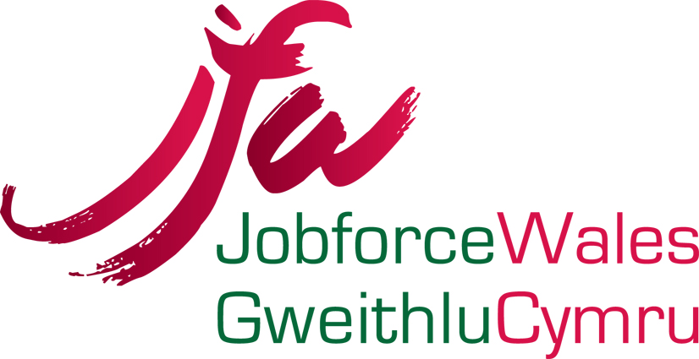 JOB DESCRIPTION

Job Title: Business Support Assistant

Responsible to: Senior Officer/Company Manager

Job Purpose: To provide an administration and business support service within the Company.

Principal Responsibilities

- To operate administrative procedures and Company systems to support the efficient and effective management and delivery of the company’s work based learning contract. .
- To provide administrative support to the Senior Officer Administration/HR and other company staff.
- To accurately input LLWR data onto the Maytas database system, and subsequent processing associated with learner files to ensure that documentation is correctly processed.
- To accurately input all information, including learner progress reviews and health and safety vetting and monitoring documentation and ensure consistency in the data recorded.
- To accurately input learner and employer data on the SAW electronic platform, to support the recruitment of learners and to assist in the monitoring of their progress whilst on programme.
- To undertake filing and archiving of documentation to maintain the security of all information relating to the work based learning contract and compliance with GDPR requirements.
- To undertake appropriate business support activities to achieve full compliance with Welsh Government requirements relating to the delivery of the company’s work based learning contract.
- To provide business support to managers to prepare for internal and external audit and quality assurance activities.
- To support the preparation of company marketing material/activities.

- To deal with general enquiries from internal and external clients and/or organisations.
- To support Company organised events as necessary.
- To produce documentation as required using a variety of software packages e.g. Word, Excel, Access, PowerPoint and the Internet.
- To communicate and liaise with all departments across the Company.
- To carry out work on behalf of, or in collaboration with other departments.
- To act as note/minute taker at team meetings.
- To provide a reception service to learners and visitors.
- To keep abreast of changes in provision as directed by the Welsh Government and any other relevant external agencies.

- To contribute to SAW activities through working and development groups.

- To promote and ensure safe working practices in line with Health and Safety requirements.

- To play an active role in Quality.

- To actively promote the equality of opportunity and diversity agenda within the Company.

- To adhere to all Company policies and procedures.

- To undertake professional development as required.

- To undertake other appropriate duties as required by the line manager.

It should be noted that this Job Description merely provides a resume of the main duties and responsibilities of the post and will be subject to periodic review in conjunction with your Line Manager and the Company Manager, and may lead to revisions in the light of the operational requirements of the Company.

