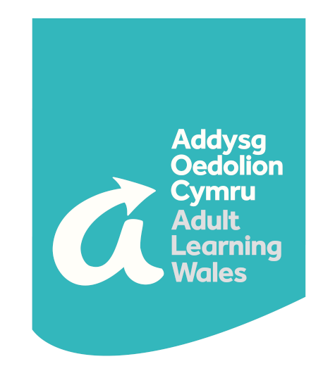
Y Coleg Cymunedol Cenedlaethol
The National Community College
Safeguarding, Prevent and
Learner Wellbeing Guidance

Covid-19 Update May 2020

Introduction

Covid-19, and the response of the UK and Welsh Government to the virus, has dramatically changed the way in which we go about our lives.

Whilst face to face teaching at AOC | ALW is currently suspended, we remain open at this time with many opportunities for online learning currently in place and further online courses being developed each day.

The health, wellbeing and safety of our learners continues to be our most important priority. We are committed to providing an environment where our learners can feel safe and secure while learning; this applies whether learning in a classroom, remotely or online.
This guidance is provided alongside AOC | ALW’s learner support and safeguarding policies, and does not replace the responsibilities, principles and expectations included within them. Instead, the guidance intends to provide some important updates regarding our approach to learner health, wellbeing and safety at this time.
We continue to monitor the current situation and to respond to advice and guidance from the Welsh Government and Public Health Wales as it becomes available. We will continue to provide updates for learners, members, branches and staff via our regional teams, our social media and our website, which includes frequently asked questions that are updated on a regular basis.
Mental Health and Wellbeing
Current restrictions will have an impact on the wellbeing of everyone, and it is easy to feel overwhelmed in these uncertain times. Mental health and wellbeing support is extremely important during a period of self-isolation and reduced social contact. Please see our website for advice and resources to support mental health and wellbeing.
Financial hardship
Our Financial Contingency Fund (FCF) is allocated for the purpose of providing additional financial support to learners with financial limitations or who face financial difficulties.

The Financial Contingency Fund is still available to eligible learners during this time to support with the purchase of relevant items such as books and course materials.

For further information regarding financial support and eligibility criteria please see our website here.

Additional Learning Needs
Addysg Oedolion Cymru | Adult Learning Wales is committed to providing an effective and supportive learning environment for all learners. Additional Learning Support (ALS) funding is allocated to AOC | ALW for the purpose of supporting learners identified as having learning difficulties and / or disabilities, so that barriers to achieving individual potential are removed and learners are more able to reach their full potential.

Learners with additional learning needs may be able to access additional one to one virtual support with online courses at this time.

As with our website, our online learning platforms are currently supported by ReciteMe accessibility software, which is available to all of our learners. Learners with additional learning needs may be able to access further specialist technical support to assist with any accessibility issues relating to online learning with us at this time.
For more information regarding additional learning support, please contact your regional team or your course tutor in the first instance, or send an email to info@adultlearning.wales
Safeguarding and Prevent
As a result of Covid-19, there is a need for increased vigilance due to the pressures on services, families and young people at this time.
Safeguarding is still everyone’s responsibility, and any concerns of a safeguarding nature should be reported to our Safeguarding Team; please see contact details below or send an email to safeguarding@adultlearning.wales
Our Safeguarding and Prevent Policy, including key contacts for safeguarding and Prevent advice, can be accessed here.
While we are self-isolating and socially distancing due to Coronavirus, social media platforms, like Twitter, Snapchat and video calls, are a great way to stay in touch with friends and family, share your thoughts and ideas and connect with like-minded people.
Unfortunately, whilst rare, there are negative influencers and online groomers who use the internet, social media and online gaming to spread their extreme ideas. Some of these ideas may be considered radical or extreme and when a person starts to support or be involved in them, this is called radicalisation.
More information on keeping you and your family safe is available here.
Online Safety
During this difficult time, we will all become more reliant on digital communication. Many people are using new services, apps or devices, such as webcams and tablets, to work or socialise. You may also be using existing devices and services more often.
To help you stay safe you should:
- Check your security and privacy settings- adjust privacy and safety settings to increase security and control the personal data you share. Be aware of your “digital footprint”- information about you that exists on the Internet as a result of your online activity.
- Block unsuitable content- it is important to understand the website or app you are using and how they do things - find out in their terms and conditions. If you see harmful activity, report it to the site. To prevent unwanted content from appearing, set filters on your home broadband and mobile networks. The UK Safer Internet Centre has advice on how to do this.
- Protect against fraud- beware of fraud and scams online including COVID-19 related phishing emails and text messages.
- Check the facts- not all information online is reliable. Before you like, comment or share something online use the SHARE checklist to make sure you’re not contributing to the spread of harmful content:
  - Source - make sure information comes from a trusted source
  - Headline- always read beyond the headline
  - Analyse- check the facts
  - Retouched- does the image look as though it has been doctored?
  - Error- look out for bad grammar and spelling
Further information on staying safe online is available here

Key Contacts
Name | Role | Contact number | Email address
Cath Hicks | Designated Safeguarding Lead /  Head of Learner Services & Resources | 07931 204613 | cath.hicks@adultlearning.wales
Martyn Reed | Learner Services Manager | 07715 904304 | martyn.reed@adultlearning.wales
Mary Morris | Human Resources Manager | 07930 688202 | mary.morris@adultlearning.wales
Rachel Burton | Youth, Community and Play Work (YCPW) Manager/ Safeguarding Officer | 07960 858835 | rachel.burton@adultlearning.wales
Jayne Ireland | Regional Manager South East Wales/ Safeguarding Officer | 07787 423632 | jayne.ireland@adultlearning.wales
Sarah O’Connell Jones | Regional Manager North Wales/ Safeguarding Officer | 07930 867908 | Sarah.O’ConnellJones@adultlearning.wales
Beth John | Regional Manager South West and Mid Wales | 07432 881123 | beth.john@adultlearning.wales

In an emergency (immediate threat or danger to life), you should always call 999

